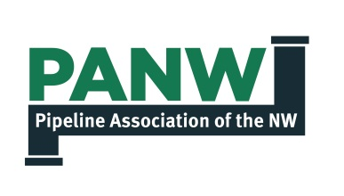

Pipeline Emergency Response Training

Objective: Develop a mutual understanding between response agencies and pipeline operators regarding coordination of response efforts
Agenda:
- Introductions
- Review Agenda and Objectives
- Pipeline Locations and Products Transported
- Leak and Hazard Information
- Communications and Coordination of Response Efforts
- Community impact and the potential protective actions that may be needed
- Capabilities Review
- Questions and General Discussion

Pipeline Emergency Response Training

Objective: Develop a mutual understanding between response agencies and pipeline operators regarding coordination of response efforts
Agenda:
- Introductions
  - Name, Organization, Office Location, Title, or Responsibilities
- Review Agenda and Meeting Objectives
  - Mutual Understanding
  - Information Exchange (Q&A at the end)
- Pipeline Locations and Products Transported
  - Transmission Pipelines – see PDF file from National Pipeline Mapping System (NPMS)
  - Gathering and Distribution pipelines – see PipeVision mapping application
- Leak and Hazard Information
  - Appendix A in Pipeline Emergency Response Guidelines (PERG)
  - Incident Response Steps handout
- Communications and Coordination of Response Efforts
  - Incident Response Steps - see pages 19-27 in the PERG booklet
  - Coordination – see pages 28-29 in the PERG booklet
- Community impact and the potential protective actions that may be needed
  - Operator Information forms
- Response Capabilities
  - Capabilities report for the County
  - Action: Update Capabilities Form
- Questions and General Discussion

Additional Resources: Single page Capabilities Form

